PROFILE
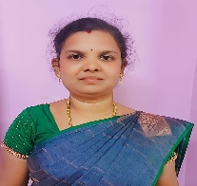
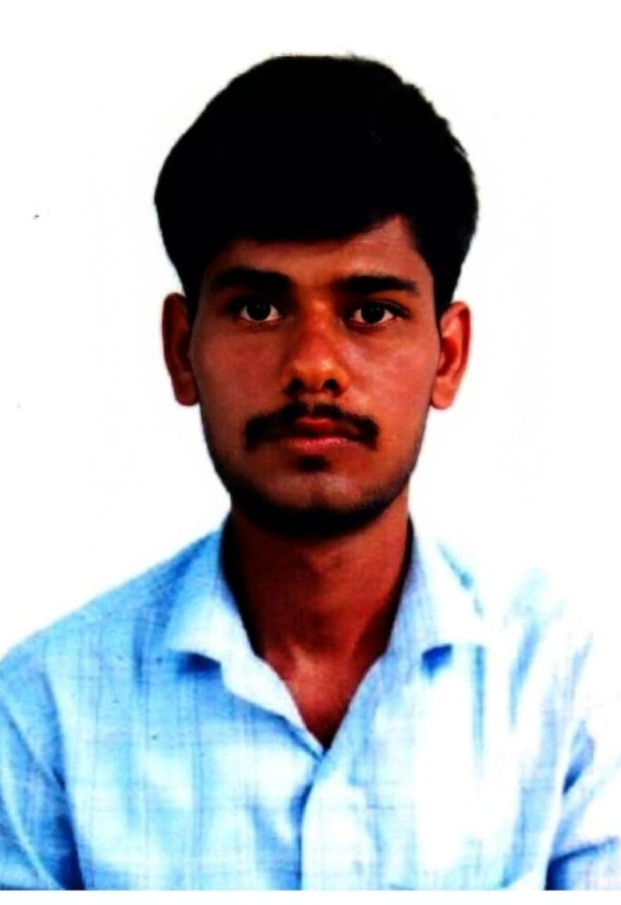

PERSONAL DETAILS
Name : Dr.N.Selvam
Date of Birth : 04.05.1980
Qualification : Assistant professor
Designation : MA.,M.Phil.,,Ph.D., NET
Department : TAMIL
Community : BC
Nationality : Indian
Email ID : tsaramani@gmail.com

ACADEMIC QUALIFICATIONS
Degree | Specialization | College | University | Year of  Passing
Ph.D | TAMIL | St.Xavier College,Palayamkottai | M.S University,Thirunelveli | 2024
NET | TAMIL | UGC | NTA | 2018
M.Phil | NIL | Annamalai University,Chidambaram | Annamalai University, Chidambaram | 2008
M.A | TAMIL | Annamalai University,Chidambaram | Annamalai University, Chidambaram | 2006
B.Lit | TAMIL | Annamalai University,Chidambaram | Annamalai University, Chidambaram | 2001
H.Sec. | TAMIL | Government Girls Hr.Sec.School,Kovilpatti | State Board | 1997
SSLC | TAMIL | Government Girls Hr.Sec.School,Kovilpatti | State Board | 1995

 | ACADEMIC IDENTITY
 | *VIDWAN ID | 714218
 | *ORCID ID
 | *SCOPUS ID | -
 | *RESEARCHER  ID/ PUBLONS ID | -
 | GOOGLE  SCHOLAR LINK | -
TEACHING EXPERIENCE
Date of Appointment |  |  | 10.06.2026
Date of Retirement |  |  | 04.05.2040
Teaching Experience
UG |  |  | 7 years
PG |  |  | -
Research

COURSES/CLASSES TAUGHT | NAME OF THE INSTITUTIONS | DURATION
COURSES/CLASSES TAUGHT | NAME OF THE INSTITUTIONS | From | To | Years
UG&PG Tamil Department  Part-1 Tamil for All UG Students | SSDM College,Kovilpatti | 14.06.2019 | 27.04.2026 | 7 years
UG Part-1 Tamil for All UG Students | GVN College,Kovilpatti | 10.06.2026 | Till

AWARDS RECEIVED
1. | md;id njurh tpUJ
2. | ngUikkpF ngz; tpUJ
3. | ijay; ehafp tpUJ

ADMINISTRATIVE EXPERIENCE
S. No | DESIGNATION | INSTITUTIONS | YEAR
1. | Assistant Professor | SSDM College,Kovilpatti | 7 years
2.
3.
4.
5.

ORIENTATION / REFRESHER COURSES / FACULTY DEVELOPMENT
PROGRAMME UNDERGONE
S. No | Name of the Training | Name of the  Sponsoring Agency | Place and Date
1. | ,iza top gd;dhl;Lg; gapyuq;fk; - Muha;r;rp newpKiwfs; | jp ];lhz;lu;L gau; xu;f;]; ,uhruj;jpdk; kfspu; fy;Y}up> (jd;dhl;rp) rptfhrp. | jp ];lhz;lu;L gau; xu;f;]; ,uhruj;jpdk; kfspu; fy;Y}up> (jd;dhl;rp) rptfhrp.  24.06.2021-30.06.2021
2. | KJfiy kw;Wk; jkpoha;Tj;Jiw – mnkupf;fh> jkpo; mepjk; - gd;dhl;L mstpyhd Mrpupau; jpwd; Nkk;ghl;L epfo;T – vspa Kiwapy; fzpdp El;gq;fs; | jp ];lhz;lu;L gau; xu;f;]; ,uhruj;jpdk; kfspu; fy;Y}up> (jd;dhl;rp) rptfhrp. | jp ];lhz;lu;L gau; xu;f;]; ,uhruj;jpdk; kfspu; fy;Y}up> (jd;dhl;rp) rptfhrp  19.02.2024-23.02.2024
3. | Tpdhj;jhs; cUthf;fKk; kjpg;gPl;L cj;jpfSk; - gapyuq;fk; | ; NTS - J}a rNtupahu; fy;Y}up (jd;dhl;rp) ghisaq;Nfhl;il | J}a rNtupahu; fy;Y}up (jd;dhl;rp) ghisaq;Nfhl;il 21.10.2024
4 | b[pl;ly; cyfj;jpy; tpdhj;jhs; tbtikg;Gk;> kjpg;gPl;L cj;jpfSk;. gapyuq;fk; | NTS -J}a rNtupahu; fy;Y}up (jd;dhl;rp) ghisaq;Nfhl;il | J}a rNtupahu; fy;Y}up (jd;dhl;rp) ghisaq;Nfhl;il 14.10.2025
5 | nrk;nkhopj;jkpOk; nraw;if Ez;zwpTk; - gapyuq;fk; | nrk;nkhopj; jkpoha;T kj;jpa epWtdk; - nrd;id | nrk;nkhopj; jkpoha;T kj;jpa epWtdk; - nrd;id  23.06.2026 – 29.06.2026

DETAILS OF RESEARCH WORK
Research Stages | Title of the Thesis | University where the work was carried  out
Ph.D | jkpo; ,yf;fpaq;fspy; $e;jYk; fUj;Jg;  GidT nkhopAk;. | M.S University
M.Phil | jpUney;Ntyp fhe;jpkjpak;ik gps;isj;jkpo;  fhl;Lk; rKjhak;; | Annamalai University  Chidambaram.
M.A

B.A

AREAS OF RESEARCH
NIL

PH.D. THESIS ADJUDICATED:
S.No | Name of the University | Title of the Thesis/ Name of Candidate/Year
1 | NIL

STUDENT RESEARCH PROJECTS GUIDED
S. No | Student Name | Title of the Project | Year
1. | NIL
2.
3.

PUBLICATIONS
BOOKS | BOOK CHAPTERS | SCOPUS | WEB OF SCIENCE | UGC LISTED
NIL |  | NIL
OTHER INDEXED | AS A
 | RESOURCE
 | PERSON

PUBLICATIONS: SCOPUS INDEXED JOURNALS&WEB OF SCIENCE
 | S.  No |  | Title of the Paper |  | Name of the Journal |  |  | ISSN No., Volume, Issue, Impact factor & Pg. No
 | 1. |  | NIL
 | 2.
 | 3.
PUBLICATIONS: UGC LISTED JOURNALS
S.  No |  | Title of the Paper |  |  |  | Name of the Journal |  |  | ISSN No., Volume, Issue, Impact factor & Pg. No
1. |  | $e;jYk; GidTk; |  |  |  | etPd jkpoha;T |  |  | ISSN : 2321 – 984X
2. |  | jkpo; ,yf;fpaq;fspy; $e;jy;;; |  |  |  | etPd jkpoha;T |  |  | ISSN : 2324 – 984X
3. |  | FWe;njhifapy; $e;jy; tifg;ghL |  |  |  | Ijtlls Journal |  |  | E- ISSN : 2581 -7140
4.
5.

PUBLICATIONS: OTHER INDEXED JOURNALS
S.  No | Title of the Paper | Name of the Journal | ISSN No., Volume,  Issue, Impact factor &Pg.No
1. | rq;f ,yf;fpaj;jpy; KUfd; topghL; | nrk;Gyk; gd;dhl;Lj; jkpohuha;r;rpf; fhyhz;bjo; | ISSN 2278-1641
2. | rq;f fhyr; rKjhaj;jpy; $e;jy; | rhd;yhf;]; gd;dhl;Lj; jkpopay; Ma;tpjo; | E - ISSN : 2582 -2810
3. | rq;f fhyg; ngz;fspd; tPuk; | rhd;yhf;]; gd;dhl;Lj; jkpopay; Ma;tpjo; | E-ISSN :2582 -0397

AS A RESOURCE PERSON
S. No | Name of the Event | Name of the Sponsoring Agency | Place and Date
1. | fk;guhkhazk; - rpwg;Gr; nrhw;nghopT. | Nfhtpy;gl;bf; fk;gd; fofk; | Nfhtpy;gl;b  26.05.2024
2. | jpUf;Fws; - rpwg;Gr; nrhw;nghopT. | jpUts;Stu; fofk; | fOFkiy  05.10.2025
3. | cyf rhjid epfo;T – 144 MSikfs; - 144 kzp Neuk; - kfhftp ghujp – rpwg;Gr; nrhw;nghopT. | jkpo;ehL jkpo;r; rq;fk; - ,e;J rka mwepiyaj;Jiwapd; g+k;Gfhu; fy;Y}up jd;dhl;rp  neju;yhe;J R+upaj; jkpo;j; njhiyf;fhl;rp –  A+dpl;b Adptu;]; Ntu;y;l; nuf;fhu;l;- ngq;fSU | ,izatop  14.11.2025

WEBMINARS/SEMINARS/ CONFERENCES / SYMPOSIA / WORKSHOP
PAPER PRESENTED: National - International -
S.  No | Name of the Event | Name of the  Sponsoring Agency | Place and Date
1. | gd;dhl;L Ma;T fUj;juq;fk; - rq;ffhyg; ngz;fspd; $e;jy; xg;gidAk;> mofpay; rpe;jidAk;. | J}a rNtupahu; fy;Y}up jd;dhl;rp | ghisaq;Nfhl;il  16.12.2013
2. | Njrpaf; fUj;juq;fk; - ew;wpizapy; jhtuq;fs; | jpahfp ju;kf;fz; mkpu;jk; fiy kw;Wk; mwptpay; fy;Y}up. | ,uhkehjGuk;  08.12.2016
3. | Njrpa Ma;Tf; fUj;juq;fk; - rq;ffhyg; ngz;fSk;> tpisahl;Lf;fiyAk;. | J}a rNtupahu; fy;Y}up jd;dhl;rp | ghisaq;Nfhl;il  27.02.2017
4. | Njrpa Ma;Tf; fUj;juq;fk; - xg;gidf;fiy | J}a rNtupahu; fy;Y}up jd;dhl;rp | ghisaq;Nfhl;il  27.02.2017

SEMINARS/ CONFERENCES / SYMPOSIA / WORKSHOP/ ATTENDED:
S.  No | Name of the Event | Name of the Sponsoring  Agency | Place and Date
1. | gd;dhl;Lf; fUj;juq;fk; - ,yf;fpaq;fspy; kdpj kjpg;gPLfs;. | njhd;Ngh];Nfh fiykw;Wk; mwptpay; fy;Y}up. | fPo<uhy;  09.02.2024
2. | fUj;juq;fk; - Nfhapw;fiy  ,izatop | nj$;z khw ehlhu; fy;Y}up | jpUney;Ntyp  17.05.2021
3. | fUj;juq;fk; - ,yf;fpa fl;likg;Gk;> kdpj mwKk;.  ,izatop | ehd;fhk; jkpo;r;rq;fk; - kJiu nre;jkpo; fiy kw;Wk; fPo;j;jpirf; fy;Y}up. | kJiu  08.06.2021
4. | ftpauq;fk; - ghujpahu; ftpijfs;  ,izatop | jtj;jpU rhe;jypq;f mbfshu; fiy mwptpay; jkpo; fy;Y}up. | Nfhit  11.06.2021
5. | jpwdwpTj;Nju;T – jkpowpQu;fs;  ,izatop | jp ];lhz;lu;L gau; xu;f;]; ,uhruj;jpdk; kfspu; fy;Y}up> (jd;dhl;rp) rptfhrp. | rptfhrp.  14.06.2021 kw;Wk; 15.06.2021
6. | gd;dhl;Lg; gapyuq;fk; - Muha;r;rp newpKiwfs; - ,izatop | jp ];lhz;lu;L gau; xu;f;]; ,uhruj;jpdk; kfspu; fy;Y}up> (jd;dhl;rp) rptfhrp | rptfhrp.  24.06.2021 – 30.06.2021
7. | rpe;jid muq;fk; - rpyk;gpy; ngz;fs; - ,izatop | v];.Mu;.vk;.  mwptpay; kw;Wk; njhopy;El;gf; fy;tp epWtdk;. | nrd;id  08.07.2021
8. | fUj;juq;fk; - jpUke;jpuj;jpd; rpe;jidj; jsq;fs; - ,izatop | jpUts;Stu; fy;Y}up | Ghgehrk;  13.07.2021
9. | fUj;juq;fk; - mfehD}Wk>; jkpo; muru;fSk; - ,izatop | lhf;lu; vk;.[p.Mu;.fy;tp kw;Wk; Muha;r;rp epWtdk; | nrd;id  22.07.2021

SEMINARS/ CONFERENCES / WORKSHOP ORGANISED :
S.  No | Name of the Event | Name of the  Sponsoring Agency | Place and Date
1 | NIL
2
3
4

REVIEWER IN INTERNATIONAL JOURNALS
S.  No | Name of the Journal | Publishers | ISSN/ EISSN
1 | NIL
2
3
4
5
6
7

MEMBERS IN PROFESSIONAL BODY

S.  No | Name of the Body | Member ID | Location of the BOdy
1 | JCI | 2023-2024 | SSDM College,Kovilpatti
2
3
4

Date : Signature

