PROFILE
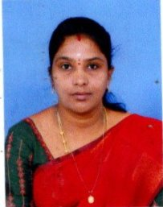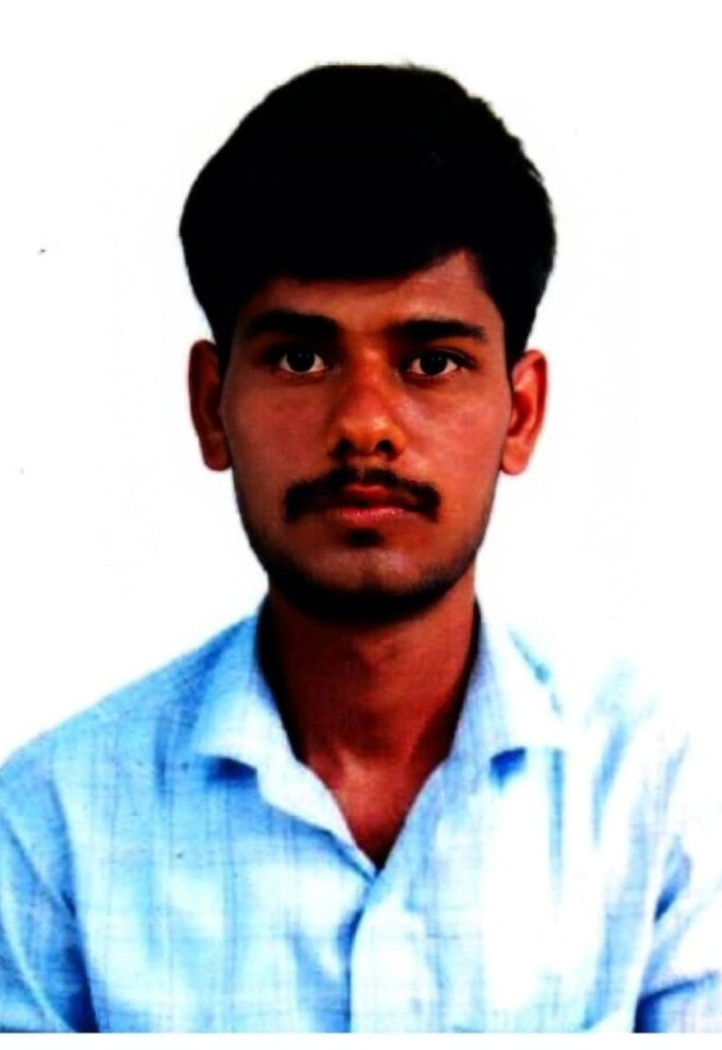

PERSONAL DETAILS
Name : Mrs.S.Barathi
Date of Birth : 18.02.1979
Qualification : Assistant professor
Designation : MA,B.Ed,MPhil,NET
Department : TAMIL
Community : BC
Nationality : Indian
Email ID : gsureshaish@gmail.com

ACADEMIC QUALIFICATIONS
Degree | Specialization | College | University | Year of  Passing
Ph.D | TAMIL | P.K.R Womens ArtsCollege,Gopichettipalayam | Bharathiyar University | Doing
NET | TAMIL | UGC | NTA | 2025
M.Phil | TAMIL | M.D.T Hindu College,Thirunelveli | M.S University,Thirunelveli | 2017
M.A | TAMIL | M.K University,Thirunelveli | M.K University,Thirunelveli | 2012
B.Ed | TAMIL | SCAD College of Education,Cheranmahadvi | Tamilnadu Education University | 2009
B.A | TAMIL | Govt Arts College for Women,Thirunelveli | M.S University,Thirunelveli | 2000
H.Sec. | TAMIL | MPL Girls Hr.Sec.School  Thirunelveli | State Borde | 1996
SSLC | TAMIL | MPL Girls Hr.Sec.School  Thirunelveli | State Borde | 1994

 | ACADEMIC IDENTITY
 | *VIDWAN ID | 714234
 | *ORCID ID
 | *SCOPUS ID | -
 | *RESEARCHER  ID/ PUBLONS ID | -
 | GOOGLE  SCHOLAR LINK | -
TEACHING EXPERIENCE
Date of Appointment |  |  | 10.06.2026
Date of Retirement |  |  | 18.02.2039
Teaching Experience
UG |  |  | 3 years 8 Months
PG |  |  | -
Research

COURSES/CLASSES TAUGHT | NAME OF THE INSTITUTIONS | DURATION
COURSES/CLASSES TAUGHT | NAME OF THE INSTITUTIONS | From | To | Years
UG Part-1 Tamil for All UG Students | Unnamalai College Arts &Science ,Kovilpatti | 16.08.2022 | 30.04.2026 | 3yrs 8 Months
UG Part-1 Tamil for All UG Students | G.V.N College | 10.06.2026 | Till
AWARDS RECEIVED
thpir vz; | ehs; | tpUJfspd; ngah; | toq;fpath;fspd; tpguq;;fs;
1 | 15.09.2025 | ஞானகுரு | கோவில்பட்டி சென்ட்ரல் அரிமா சங்கம் மற்றும் மனோன்மணியம் சுந்தரனார் பல்கலைக்கழகம் கோவில்பட்டி கல்வி மையம்
2. | 11.12.2025 | Rising Bharat Star Award | Worthy Wellness Foundation Trust

ADMINISTRATIVE EXPERIENCE
S. No | DESIGNATION | INSTITUTIONS | YEAR
1. | Assistant Professor | Unnamalai College Arts &Science ,Kovilpatti | 3yrs 8 Months
2.
3.
4.
5.

ORIENTATION / REFRESHER COURSES / FACULTY DEVELOPMENT
PROGRAMME UNDERGONE
S. No | Name of the Training | Name of the  Sponsoring Agency | Place and Date
1. | Thiran Mepattu Pairchi | Annai voilat Arts and Science College,Chennai | 13.03.2025-19.03.2025
2. | Assiriyar Thiran Mepattu Pairchi | SRM Science &Tecnology, Kattankulathur | 25.11.2024-30.11.2024
3. | Faculty Development Programme | Arulmigu Palaniandavar Arts College For Women  Palani | 18.11.2022-25.11.2022
4
5
6
7.
8.
9.

DETAILS OF RESEARCH WORK
Research Stages | Title of the Thesis | University where the work was carried  out
Ph.D |  | M.S University
M.Phil
M.A |  | M.S University
B.A |  | M.S University

AREAS OF RESEARCH
NIL

PH.D. THESIS ADJUDICATED:
S.No | Name of the University | Title of the Thesis/ Name of Candidate/Year
1 | NIL

STUDENT RESEARCH PROJECTS GUIDED
S. No | Student Name | Title of the Project | Year
1. | NIL
2.
3.

PUBLICATIONS
BOOKS | BOOK CHAPTERS | SCOPUS | WEB OF SCIENCE | UGC LISTED
NIL

OTHER INDEXED | AS A | PAPERS | WEBINARS,
 | RESOURCE | PRESENTED IN | SEMINARS,
 | PERSON | NATIONAL AND | WORKSHOPS
 |  | INTERNATIONAL | ATTENDED
 |  | SEMINARS
PUBLICATIONS: BOOKS
S. No | Title of the Book | Publication | Year
1. | NIL
2.
3.
BOOK CHAPTERS
S.  No | Title of the Paper | Name of the  Book | ISSN No., Pg.No
1. | NIL
2.

PUBLICATIONS: SCOPUS INDEXED JOURNALS&WEB OF SCIENCE
 | S.  No |  | Title of the Paper |  | Name of the Journal |  |  | ISSN No., Volume, Issue, Impact factor & Pg. No
 | 1. |  | NIL
 | 2.
 | 3.
PUBLICATIONS: UGC LISTED JOURNALS
S.  No |  | Title of the Paper |  |  |  | Name of the Journal |  |  | ISSN No., Volume, Issue, Impact factor & Pg. No
1. |  | NIL
2.
3.
4.
5.

PUBLICATIONS: OTHER INDEXED JOURNALS
S.  No | Title of the Paper | Name of the Journal | ISSN No., Volume,  Issue, Impact factor &Pg.No
1.
2.

AS A RESOURCE PERSON
S. No | Name of the Event | Name of the Sponsoring Agency | Place and Date
1. | NIL
2.
3.

WEBMINARS/SEMINARS/ CONFERENCES / SYMPOSIA / WORKSHOP
PAPER PRESENTED: National - International -
S.  No | Name of the Event | Name of the  Sponsoring Agency | Place and Date
1. | NIL
2.
3.
4.

SEMINARS/ CONFERENCES / SYMPOSIA / WORKSHOP/ ATTENDED:
S.  No | Name of the Event | Name of the Sponsoring  Agency | Place and Date
1. | AI-Driven Venture-Building Platforms Workshop | M S University ,Tirunelveli | 22.03.2024
2. | Whack of Technology on Womens Esprit | M S University ,Tirunelveli | 19.01.2024
3.

SEMINARS/ CONFERENCES / WORKSHOP ORGANISED :
S.  No | Name of the Event | Name of the  Sponsoring Agency | Place and Date
1
2
3
4

REVIEWER IN INTERNATIONAL JOURNALS
S.  No | Name of the Journal | Publishers | ISSN/ EISSN
1 | நாச்சியார் திருமொழிப் பாடல்களில் சமய நம்பிக்கைகள் | சான்லாக்ஸ்  ஐந்தமிழ் ஆய்வு மன்றம் | ISSN-2454-3993
2 | தலித் எழுத்தாளர்களின் பெண்ணியச் சிந்தனைகள் | பன்னாட்டு கருத்தரங்க ஆய்வுக் கோவை | 978-81-965227
3 | புறநானூற்றில் வானவியல் கூறுகள் | அரண் பன்னாட்டுத் தமிழ் ஆய்வு மின்னிதழ் | ISSN-2582-399X
4 | சங்கஇலக்கியங்களில் உலோகவியல் | பி.கே.ஆர் மகளிர் கலை கல்லூரி,  உலகத் தமிழ்க் காப்பிய ஆராய்ச்சி நிறுவனம் | ISBN-978-93-5619-640-7
5 | நெடுநெல்வாடை கட்டிடக்கலையில் உள்ளரங்க அமைப்பு | அனைத்துலகப்பொங்குத்தமிழ்ச் சங்கம், பி.கே.ஆர் மகளிர் கலை கல்லூரி,
6
7

MEMBERS IN PROFESSIONAL BODY

S.  No | Name of the Body | Member ID | Location of the BOdy
1 | Cultural club |  | Unnamalai college of Arts and Science,kovilpatti
2
3
4

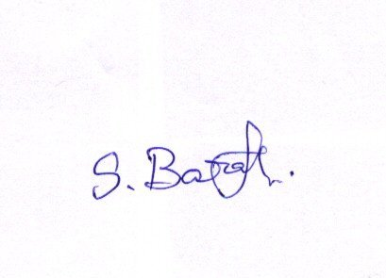

Date : Signature

